Mobile Application Development
Section W1
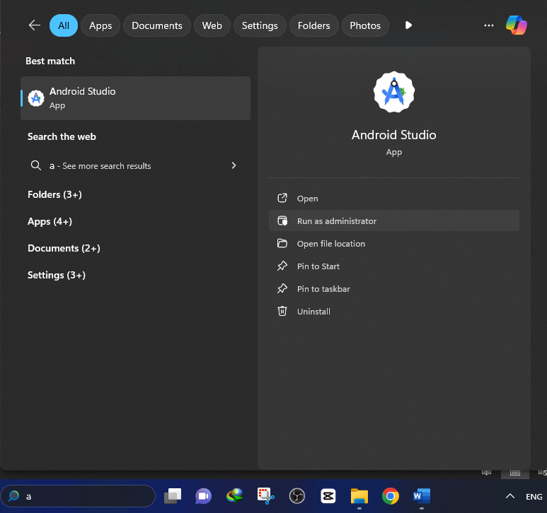

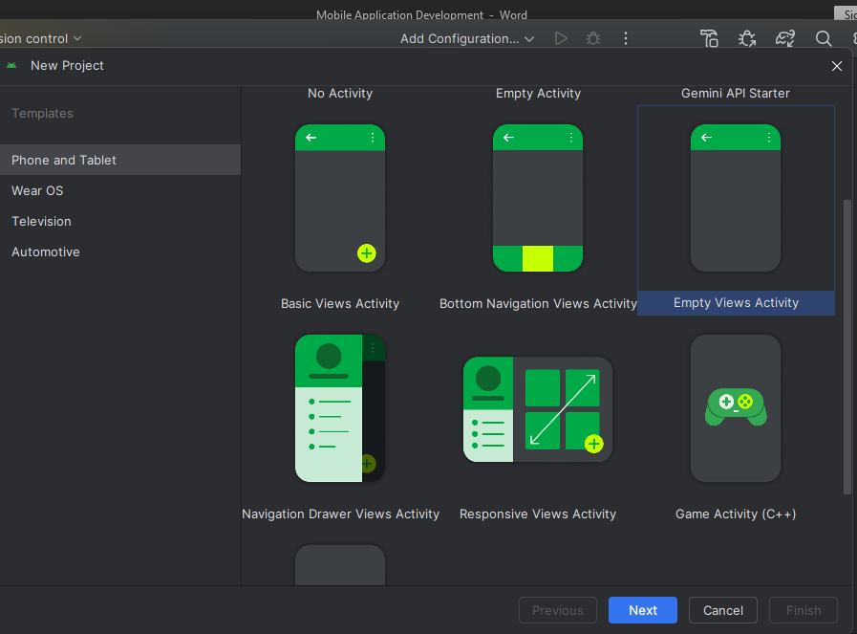

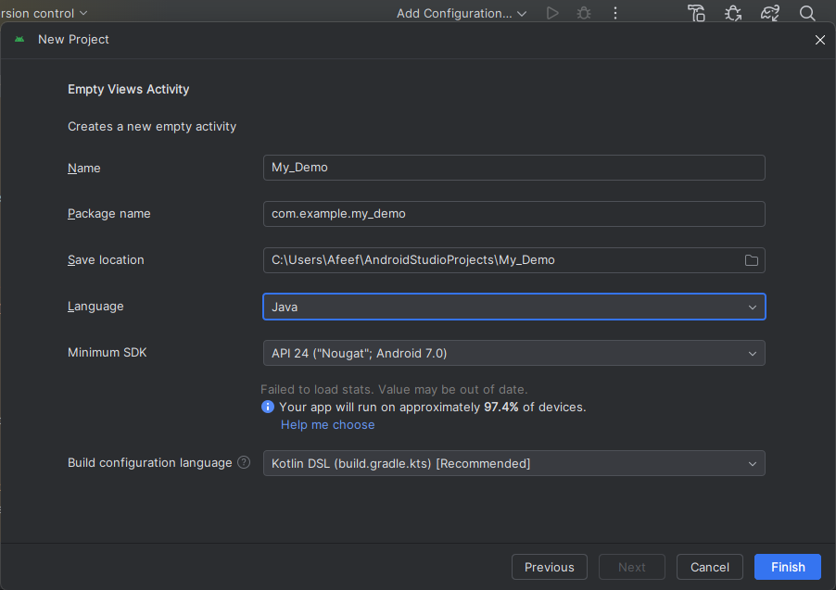
Package name: Link
Two ways get outer:
- Mobile (Setting/About Phone/USB Debugging - turn on) Build No. (click 5 time)
- Emulator
Error
Build.guide.kts (.app)
CompileSdk = 34 (if error found)
- App
- Gradle Scripts (Setting)
- Dependency (if we want to add Library)
App
- Manifests (starting point of Application) (Services integrate)
- Java ()
- Resource (Res) ()
Java: Class name and file name should be same

Resource
- Drawable (For Design, image)
- Layout
- Mipmap
- Values (color) (String)
- Theme

Task
My App 1
Res > Layout

First Name
Last Name
Your Full Name is
Enter

